SIMATS ENGINEERING (SAVEETHA SCHOOL OF ENGINEERING)
Department of Computer Science and Engineering

ASSESSMENT TOOL 3 – DEBUGGING & OPTIMISATION TASK
Course Code: | CSA0620 | Course Title: | Design and Analysis of Algorithms
CO Assessed: | CO2 – Manipulation (BL1, BL2, BL3) | Assessment: | Assessment Tool 3 – Debugging & Optimisation Task
Weightage: | 10% of CIA | Total Marks: | 100
CO2 Statement: | Apply Brute Force technique to solve sorting, searching, Closest-Pair and Convex-Hull problems (BL1, BL2, BL3)
Student Name: | R.NANDHINI | Reg. No.: | 192524355
Section / Batch: |  | Date:
Instructions to Students
- Answer the following question. Total Marks: 100.
- Carefully analyze the given program/code segment before identifying errors.
- Clearly identify logical, syntactical, and performance-related issues in the code.
- Apply systematic debugging techniques to correct the errors effectively.
- Optimize the given solution by improving efficiency, reducing unnecessary computations, or enhancing time complexity wherever possible.
- Provide proper justification for all corrections and optimization decisions.
- Write clean, structured, and well-documented code with appropriate comments.
- Maintain clarity, logical reasoning, and technical accuracy throughout the solution.

Question Type | Focus Area | Questions
Debugging & Optimisation Task | Identify errors, debug programs, and optimize algorithm efficiency using appropriate techniques | Q1

SECTION A – DEBUGGING & OPTIMISATION TASK

What was the error?

Incorrect code:

for (j = 0; j <= n - i - 1; j++) // ERROR

Why is it wrong?

The condition <= allows j to become n - i - 1.

Then the statement arr[j + 1] accesses arr[n - i].

In the first pass (i = 0), this becomes arr[n], which is outside the array (out-of-range access).

This may cause incorrect output or a runtime error.

What was corrected?

Incorrect

for (j = 0; j <= n - i - 1; j++)

Correct

for (j = 0; j < n - i - 1; j++)

Reason:

Using < ensures that j + 1 is always a valid index.

Each pass compares only valid adjacent elements.

The largest element moves to the end after every pass.

Correct and Optimized C Program

#include <stdio.h>

// Function to perform Bubble Sort

void bubbleSort(int arr[], int n)

{

int i, j, temp;

int swapped;

// Outer loop for passes

for(i = 0; i < n - 1; i++)

{

swapped = 0; // Reset swap flag for each pass

// Compare adjacent elements

for(j = 0; j < n - i - 1; j++)

{

if(arr[j] > arr[j + 1])

{

// Swap elements

temp = arr[j];

arr[j] = arr[j + 1];

arr[j + 1] = temp;

swapped = 1;

}

}

// Stop if no swaps occurred

if(swapped == 0)

{

break;

}

}

}

int main()

{

int n, i;

printf("Enter number of elements: ");

scanf("%d", &n);

int arr[n];

printf("Enter the elements:\n");

for(i = 0; i < n; i++)

{

scanf("%d", &arr[i]);

}

bubbleSort(arr, n);

printf("Sorted array:\n");

for(i = 0; i < n; i++)

{

printf("%d ", arr[i]);

}

return 0;

}

Sample Input

Enter number of elements: 5

Enter the elements:

64 34 25 12 22

Sample Output

Sorted array:

12 22 25 34 64

Step-by-Step Debugging

Found incorrect loop condition:

j <= n - i - 1

This caused access to:

arr[j + 1]

where j + 1 could become n, which is outside the array.

Changed the loop to:

j < n - i - 1

so j + 1 is always within the array.

Added a swap flag (swapped).

If no swaps occur in a pass, the array is already sorted.

The algorithm stops early, improving efficiency.

Time Complexity
Case | Complexity
Best Case (Already Sorted) | O(n)
Average Case | O(n²)
Worst Case (Reverse Sorted) | O(n²)

Space Complexity

O(1) (in-place sorting)

CODE:

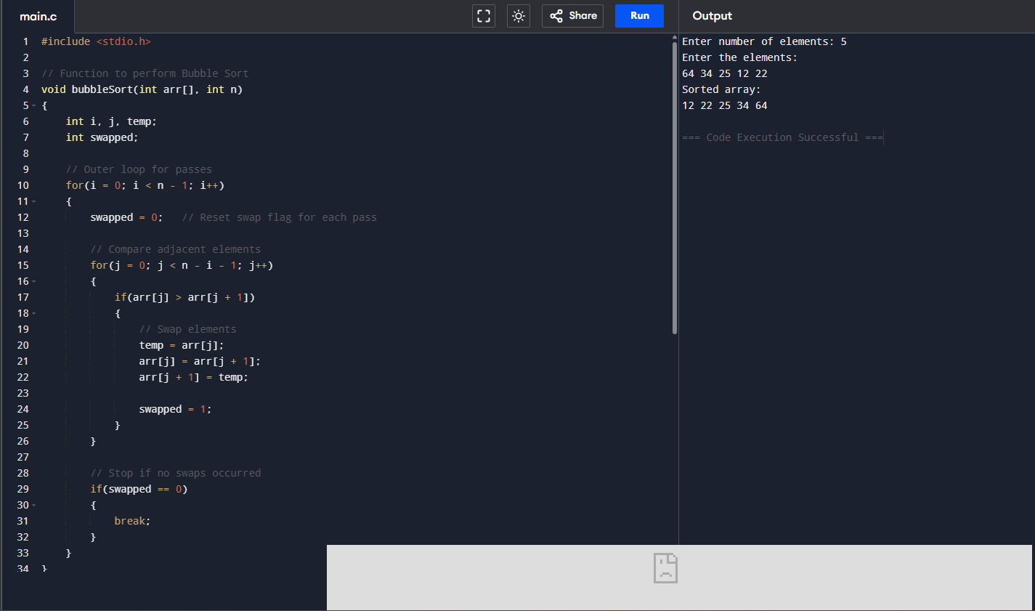

Code of Conduct
I (Name / Reg No) certify that this submission is my original work and that I have adhered to the guidelines specified for this assessment. I understand that any violation of academic integrity rules will result in disciplinary action.
Signature of the Student:

RUBRICS FOR CALCULATION

Criteria | Wt. | Level 4 – Exemplary | Level 3 – Proficient | Level 2 – Developing | Level 1 – Beginning
Problem Identification | 20% | Accurately identifies all errors and root causes with clear understanding | Identifies most errors with minor gaps | Identifies some errors but misses key issues | Unable to identify errors correctly
Debugging | 25% | Applies systematic debugging techniques effectively to resolve issues | Uses appropriate debugging methods with minor errors | Limited debugging approach; requires guidance | Unable to debug or resolve issues
Optimization | 20% | Optimizes code by significantly improving time complexity using efficient algorithms | Improves time complexity with minor gaps in efficiency | Limited improvement in time complexity | No improvement; inefficient approach retained
Analysis | 20% | Demonstrates strong logical reasoning and clear justification of solutions | Shows reasonable analysis with some justification | Limited analysis; weak reasoning | No analytical reasoning demonstrated
Code Quality | 15% | Produces clean, well-structured code with proper comments and documentation | Code is mostly clear with minor documentation gaps | Code lacks structure and proper documentation | Poorly written code with no documentation

Marks Evaluation:
Criteria | Wt. | Level 4 – Exemplary | Level 3 – Proficient | Level 2 – Developing | Level 1 – Beginning
Problem Identification | 20%
Debugging | 25%
Optimization | 20%
Analysis | 20%
Code Quality | 15%
Total Marks (100):

Faculty In-charge | Course Coordinator | Head of Department
Name: | Name: | Name:
Signature: | Signature: | Signature:
Date: | Date: | Date:

